INTERRELATIONSHIP DIAGRAPH

Purpose
To determine driving forces contributing to a problem in order to focus the resources which will be applied to the improvement.
Example:
Directions
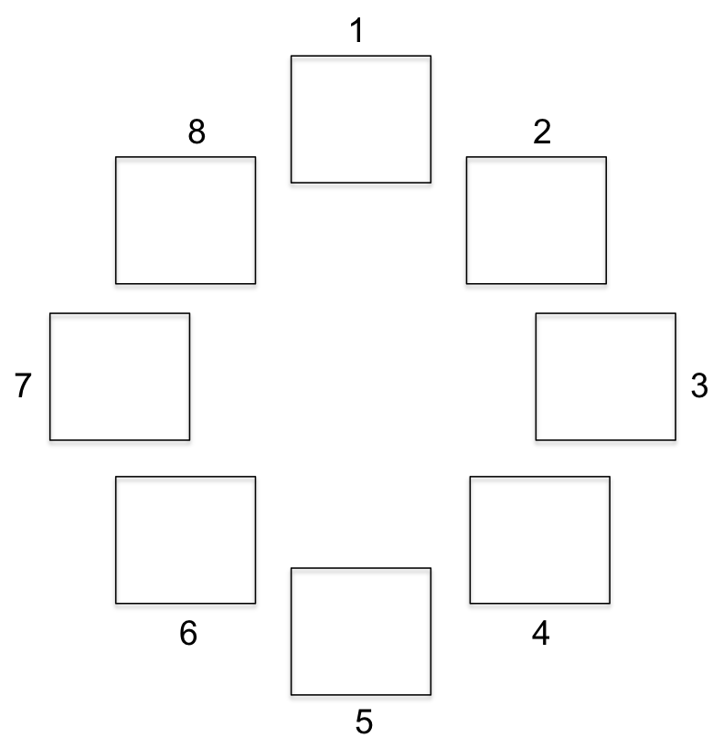
- Display headers from a problem sorting affinity diagram in a circle and number them clockwise (1, 2, 3, 4, etc.).

- Analyze relationships between header categories working always in a clockwise direction (never clockwise).

- Ask two questions of each relationship between headers.
  - Is there a significant relationship between these two things?
  - If yes, which is the driver? (If no, do nothing and move on to the next header).

Example:
- Draw an arrow between the headers which have a relationship. Have arrow start at the driver box, with the point of the arrow touching the box being driven.
No Job
No Money

- When all relationships have been considered between all boxes, count the number of arrows leaving each box and the number entering each box and record as follows:

7 leaving / 3 entering - display as 7/3

- The left number ranks the strength of the driver while the right side ranks the strength of the one being driven by something else:
7 / 3
Example:
driver / driven by

- Focus major resources on drivers to gain the most improvement on the problem

Source: The Coaching Experience: A Transformational Journey

